|  |  |  |  |
| --- | --- | --- | --- |
| **Data Set Name** | MYDATA.EUROPEAN_EMPLOYMENT | **Observations** | 30 |
| **Member Type** | DATA | **Variables** | 11 |
| **Engine** | V9 | **Indexes** | 0 |
| **Created** | Friday, December 07, 2012 08:52:07 PM | **Observation Length** | 120 |
| **Last Modified** | Friday, December 07, 2012 08:52:07 PM | **Deleted Observations** | 0 |
| **Protection** |  | **Compressed** | NO |
| **Data Set Type** |  | **Sorted** | NO |
| **Label** |  |  |  |
| **Data Representation** | SOLARIS_X86_64, LINUX_X86_64, ALPHA_TRU64, LINUX_IA64 |  |  |
| **Encoding** | utf-8 Unicode (UTF-8) |  |  |

| **Engine/Host Dependent Information** | |
| --- | --- |
| **Data Set Page Size** | 131072 |
| **Number of Data Set Pages** | 1 |
| **First Data Page** | 1 |
| **Max Obs per Page** | 1090 |
| **Obs in First Data Page** | 30 |
| **Number of Data Set Repairs** | 0 |
| **Filename** | /courses/u_northwestern.edu1/i_833463/c_3505/SAS_Data/european_employment.sas7bdat |
| **Release Created** | 9.0301M1 |
| **Host Created** | Linux |
| **Inode Number** | 13243902 |
| **Access Permission** | rw-r--r-- |
| **Owner Name** | chadrbhatti |
| **File Size (bytes)** | 262144 |

| **Alphabetic List of Variables and Attributes** | | | | |
| --- | --- | --- | --- | --- |
| **#** | **Variable** | **Type** | **Len** | **Format** |
| **3** | AGR | Num | 8 | 8.1 |
| **7** | CON | Num | 8 | 8.1 |
| **1** | COUNTRY | Char | 35 | $35. |
| **9** | FIN | Num | 8 | 8.1 |
| **2** | GROUP | Char | 10 | $10. |
| **5** | MAN | Num | 8 | 8.1 |
| **4** | MIN | Num | 8 | 8.1 |
| **6** | PS | Num | 8 | 8.1 |
| **8** | SER | Num | 8 | 8.1 |
| **10** | SPS | Num | 8 | 8.1 |
| **11** | TC | Num | 8 | 8.1 |

| **Obs** | **COUNTRY** | **GROUP** | **AGR** | **MIN** | **MAN** | **PS** | **CON** | **SER** | **FIN** | **SPS** | **TC** |
| --- | --- | --- | --- | --- | --- | --- | --- | --- | --- | --- | --- |
| **1** | Belgium | EU | 2.6 | 0.2 | 20.8 | 0.8 | 6.3 | 16.9 | 8.7 | 36.9 | 6.8 |
| **2** | Denmark | EU | 5.6 | 0.1 | 20.4 | 0.7 | 6.4 | 14.5 | 9.1 | 36.3 | 7.0 |
| **3** | France | EU | 5.1 | 0.3 | 20.2 | 0.9 | 7.1 | 16.7 | 10.2 | 33.1 | 6.4 |
| **4** | Germany* | EU | 3.2 | 0.7 | 24.8 | 1.0 | 9.4 | 17.2 | 9.6 | 28.4 | 5.6 |
| **5** | Greece | EU | 22.2 | 0.5 | 19.2 | 1.0 | 6.8 | 18.2 | 5.3 | 19.8 | 6.9 |

|  |  |
| --- | --- |
| **9 Variables:** | AGR MIN MAN PS CON SER FIN SPS TC |

| **Simple Statistics** | | | | | | |
| --- | --- | --- | --- | --- | --- | --- |
| **Variable** | **N** | **Mean** | **Std Dev** | **Sum** | **Minimum** | **Maximum** |
| **AGR** | 30 | 12.18667 | 12.30690 | 365.60000 | 0 | 55.50000 |
| **MIN** | 30 | 3.44667 | 8.86573 | 103.40000 | 0 | 37.30000 |
| **MAN** | 30 | 20.28667 | 9.45679 | 608.60000 | 0 | 38.70000 |
| **PS** | 30 | 0.80000 | 0.62090 | 24.00000 | 0 | 2.20000 |
| **CON** | 30 | 7.53000 | 2.73309 | 225.90000 | 0.60000 | 16.90000 |
| **SER** | 30 | 15.63667 | 5.16016 | 469.10000 | 3.30000 | 24.50000 |
| **FIN** | 30 | 6.65000 | 3.98668 | 199.50000 | 0 | 15.30000 |
| **SPS** | 30 | 26.99333 | 8.73206 | 809.80000 | 0 | 41.60000 |
| **TC** | 30 | 6.45333 | 1.23337 | 193.60000 | 3.00000 | 8.80000 |

| **Pearson Correlation Coefficients, N = 30 Prob > |r| under H0: Rho=0** | | | | | | | | | |
| --- | --- | --- | --- | --- | --- | --- | --- | --- | --- |
|  | **AGR** | **MIN** | **MAN** | **PS** | **CON** | **SER** | **FIN** | **SPS** | **TC** |
| **AGR** | 1.00000 | 0.31607 0.0888 | -0.25439 0.1749 | -0.38236 0.0370 | -0.34861 0.0590 | -0.60471 0.0004 | -0.17575 0.3529 | -0.81148 <.0001 | -0.48733 0.0063 |
| **MIN** | 0.31607 0.0888 | 1.00000 | -0.67193 <.0001 | -0.38738 0.0344 | -0.12902 0.4968 | -0.40655 0.0258 | -0.24806 0.1863 | -0.31642 0.0885 | 0.04470 0.8146 |
| **MAN** | -0.25439 0.1749 | -0.67193 <.0001 | 1.00000 | 0.38789 0.0342 | -0.03446 0.8565 | -0.03294 0.8628 | -0.27374 0.1433 | 0.05028 0.7919 | 0.24290 0.1959 |
| **PS** | -0.38236 0.0370 | -0.38738 0.0344 | 0.38789 0.0342 | 1.00000 | 0.16480 0.3842 | 0.15498 0.4135 | 0.09431 0.6201 | 0.23774 0.2059 | 0.10537 0.5795 |
| **CON** | -0.34861 0.0590 | -0.12902 0.4968 | -0.03446 0.8565 | 0.16480 0.3842 | 1.00000 | 0.47308 0.0083 | -0.01802 0.9247 | 0.07201 0.7053 | -0.05461 0.7744 |
| **SER** | -0.60471 0.0004 | -0.40655 0.0258 | -0.03294 0.8628 | 0.15498 0.4135 | 0.47308 0.0083 | 1.00000 | 0.37928 0.0387 | 0.38798 0.0341 | -0.08489 0.6556 |
| **FIN** | -0.17575 0.3529 | -0.24806 0.1863 | -0.27374 0.1433 | 0.09431 0.6201 | -0.01802 0.9247 | 0.37928 0.0387 | 1.00000 | 0.16602 0.3806 | -0.39132 0.0325 |
| **SPS** | -0.81148 <.0001 | -0.31642 0.0885 | 0.05028 0.7919 | 0.23774 0.2059 | 0.07201 0.7053 | 0.38798 0.0341 | 0.16602 0.3806 | 1.00000 | 0.47492 0.0080 |
| **TC** | -0.48733 0.0063 | 0.04470 0.8146 | 0.24290 0.1959 | 0.10537 0.5795 | -0.05461 0.7744 | -0.08489 0.6556 | -0.39132 0.0325 | 0.47492 0.0080 | 1.00000 |

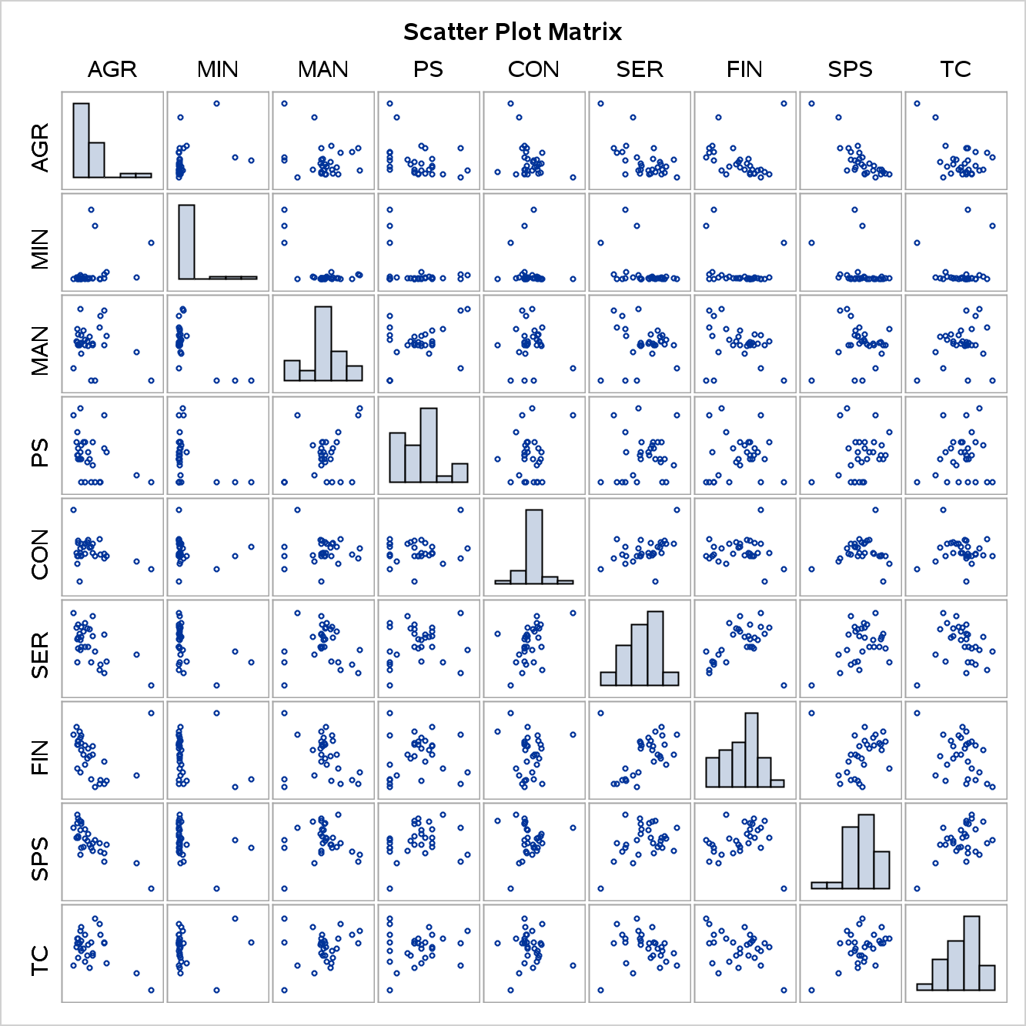

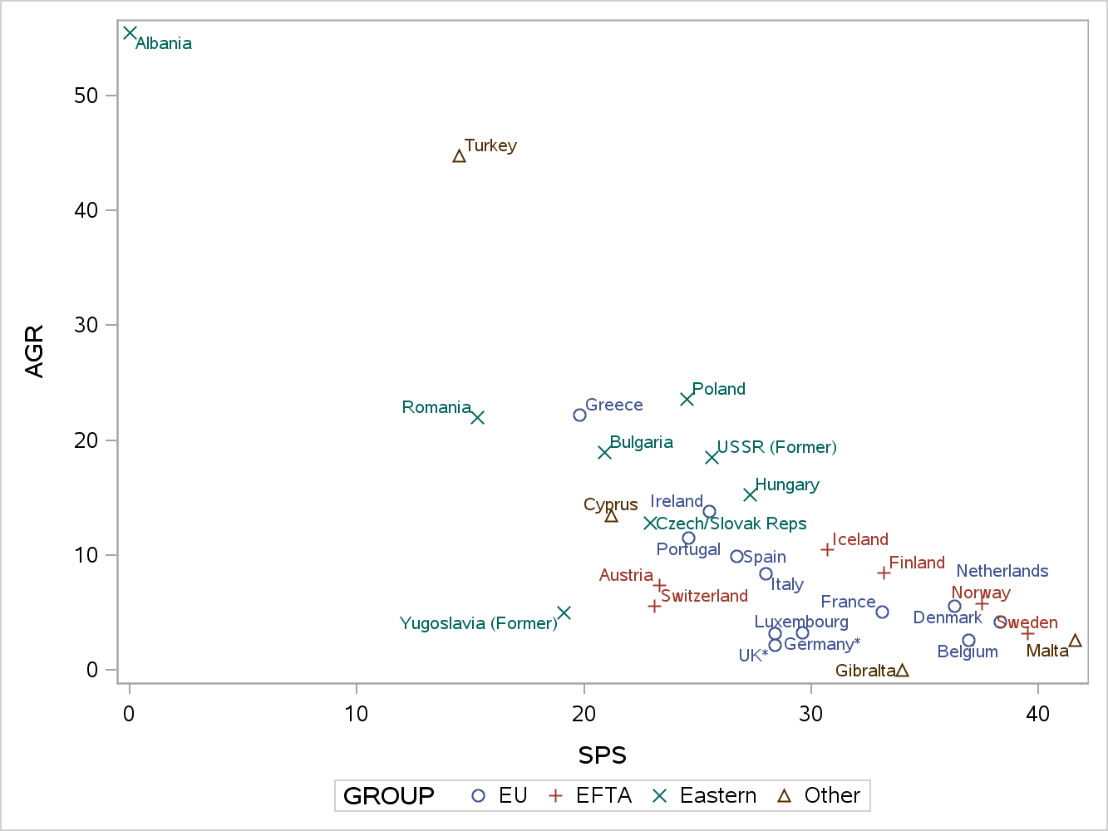

|  |  |
| --- | --- |
| **Observations** | 30 |
| **Variables** | 9 |

| **Simple Statistics** | | | | | | | | | |
| --- | --- | --- | --- | --- | --- | --- | --- | --- | --- |
|  | **AGR** | **MIN** | **MAN** | **PS** | **CON** | **SER** | **FIN** | **SPS** | **TC** |
| **Mean** | 12.18666667 | 3.446666667 | 20.28666667 | 0.8000000000 | 7.530000000 | 15.63666667 | 6.650000000 | 26.99333333 | 6.453333333 |
| **StD** | 12.30690116 | 8.865731521 | 9.45678860 | 0.6209003474 | 2.733085915 | 5.16015793 | 3.986680410 | 8.73206273 | 1.233367505 |

| **Correlation Matrix** | | | | | | | | | |
| --- | --- | --- | --- | --- | --- | --- | --- | --- | --- |
|  | **AGR** | **MIN** | **MAN** | **PS** | **CON** | **SER** | **FIN** | **SPS** | **TC** |
| **AGR** | 1.0000 | 0.3161 | -.2544 | -.3824 | -.3486 | -.6047 | -.1758 | -.8115 | -.4873 |
| **MIN** | 0.3161 | 1.0000 | -.6719 | -.3874 | -.1290 | -.4065 | -.2481 | -.3164 | 0.0447 |
| **MAN** | -.2544 | -.6719 | 1.0000 | 0.3879 | -.0345 | -.0329 | -.2737 | 0.0503 | 0.2429 |
| **PS** | -.3824 | -.3874 | 0.3879 | 1.0000 | 0.1648 | 0.1550 | 0.0943 | 0.2377 | 0.1054 |
| **CON** | -.3486 | -.1290 | -.0345 | 0.1648 | 1.0000 | 0.4731 | -.0180 | 0.0720 | -.0546 |
| **SER** | -.6047 | -.4065 | -.0329 | 0.1550 | 0.4731 | 1.0000 | 0.3793 | 0.3880 | -.0849 |
| **FIN** | -.1758 | -.2481 | -.2737 | 0.0943 | -.0180 | 0.3793 | 1.0000 | 0.1660 | -.3913 |
| **SPS** | -.8115 | -.3164 | 0.0503 | 0.2377 | 0.0720 | 0.3880 | 0.1660 | 1.0000 | 0.4749 |
| **TC** | -.4873 | 0.0447 | 0.2429 | 0.1054 | -.0546 | -.0849 | -.3913 | 0.4749 | 1.0000 |

| **Eigenvalues of the Correlation Matrix** | | | | |
| --- | --- | --- | --- | --- |
|  | **Eigenvalue** | **Difference** | **Proportion** | **Cumulative** |
| **1** | 3.11225795 | 1.30302071 | 0.3458 | 0.3458 |
| **2** | 1.80923724 | 0.31301704 | 0.2010 | 0.5468 |
| **3** | 1.49622020 | 0.43277636 | 0.1662 | 0.7131 |
| **4** | 1.06344384 | 0.35318631 | 0.1182 | 0.8312 |
| **5** | 0.71025753 | 0.39891874 | 0.0789 | 0.9102 |
| **6** | 0.31133879 | 0.01791787 | 0.0346 | 0.9448 |
| **7** | 0.29342091 | 0.08960446 | 0.0326 | 0.9774 |
| **8** | 0.20381645 | 0.20380935 | 0.0226 | 1.0000 |
| **9** | 0.00000710 |  | 0.0000 | 1.0000 |

| **Eigenvectors** | | | | | | | | | |
| --- | --- | --- | --- | --- | --- | --- | --- | --- | --- |
|  | **Prin1** | **Prin2** | **Prin3** | **Prin4** | **Prin5** | **Prin6** | **Prin7** | **Prin8** | **Prin9** |
| **AGR** | -.511492 | 0.023475 | -.278591 | 0.016492 | -.024038 | 0.042397 | -.163574 | 0.540409 | 0.582036 |
| **MIN** | -.374983 | -.000491 | 0.515052 | 0.113606 | 0.346313 | -.198574 | 0.212590 | -.448592 | 0.418818 |
| **MAN** | 0.246161 | -.431752 | -.502056 | 0.058270 | -.233622 | 0.030917 | 0.236015 | -.431757 | 0.447086 |
| **PS** | 0.316120 | -.109144 | -.293695 | 0.023245 | 0.854448 | -.206471 | -.060565 | 0.155122 | 0.030251 |
| **CON** | 0.221599 | 0.242471 | 0.071531 | 0.782666 | 0.062151 | 0.502636 | -.020285 | 0.030823 | 0.128656 |
| **SER** | 0.381536 | 0.408256 | 0.065149 | 0.169038 | -.266673 | -.672694 | 0.174839 | 0.201753 | 0.245021 |
| **FIN** | 0.131088 | 0.552939 | -.095654 | -.489218 | 0.131288 | 0.405935 | 0.457645 | -.027264 | 0.190758 |
| **SPS** | 0.428162 | -.054706 | 0.360159 | -.317243 | -.045718 | 0.158453 | -.621330 | -.041476 | 0.410315 |
| **TC** | 0.205071 | -.516650 | 0.412996 | -.042063 | -.022901 | 0.141898 | 0.492145 | 0.502124 | 0.060743 |

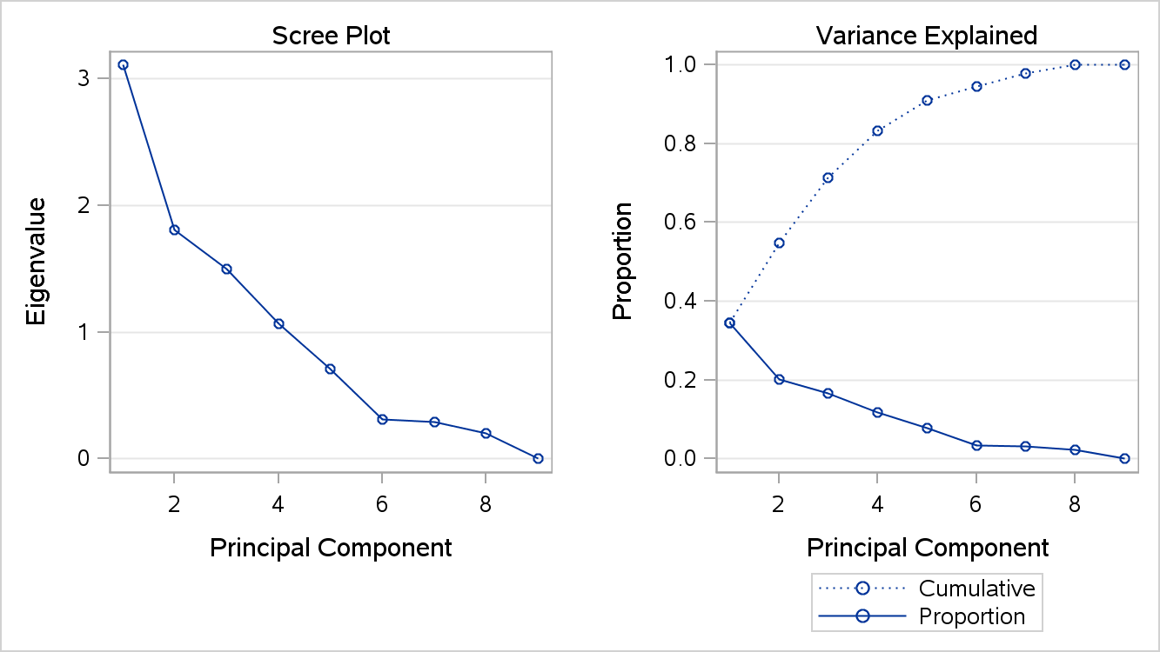

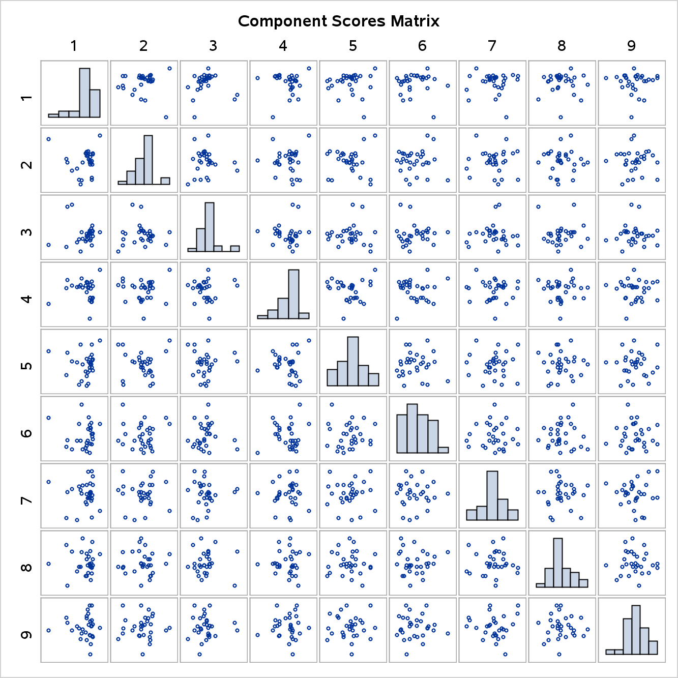

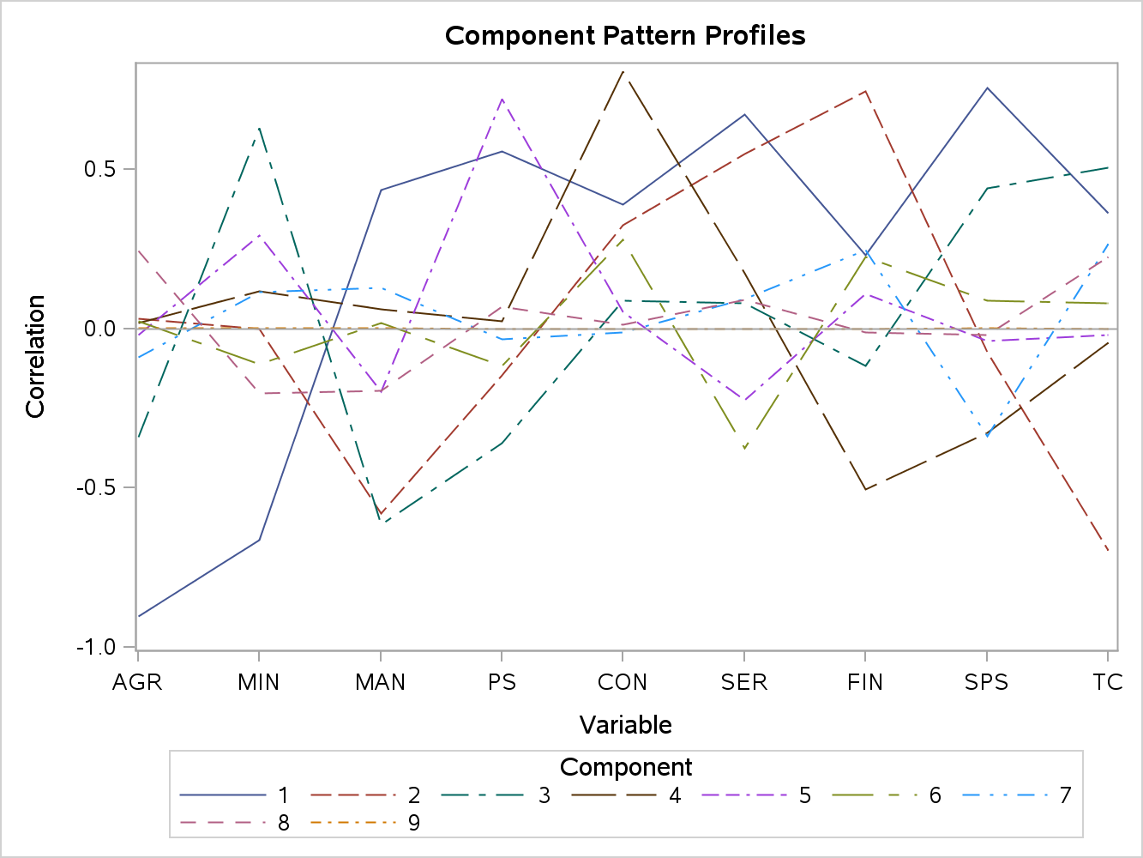

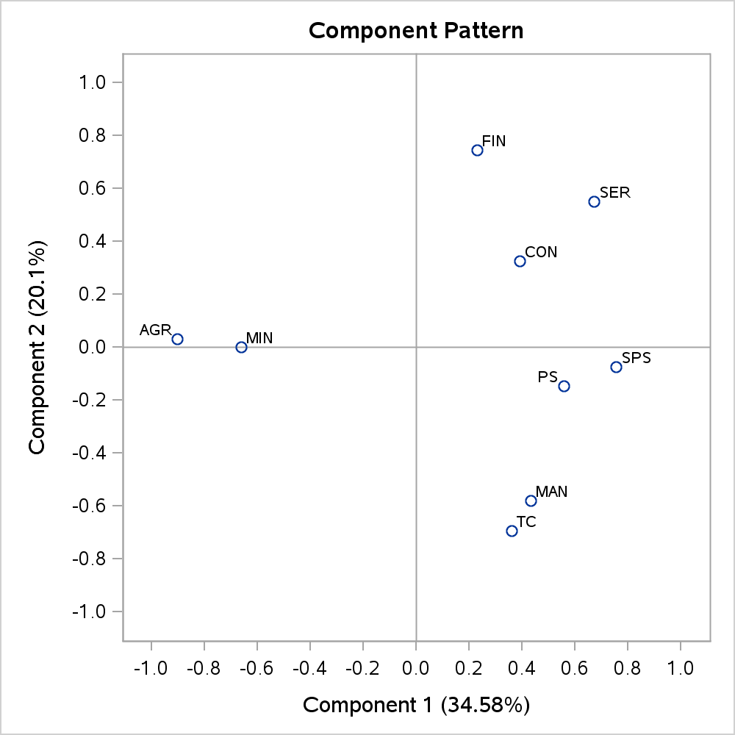

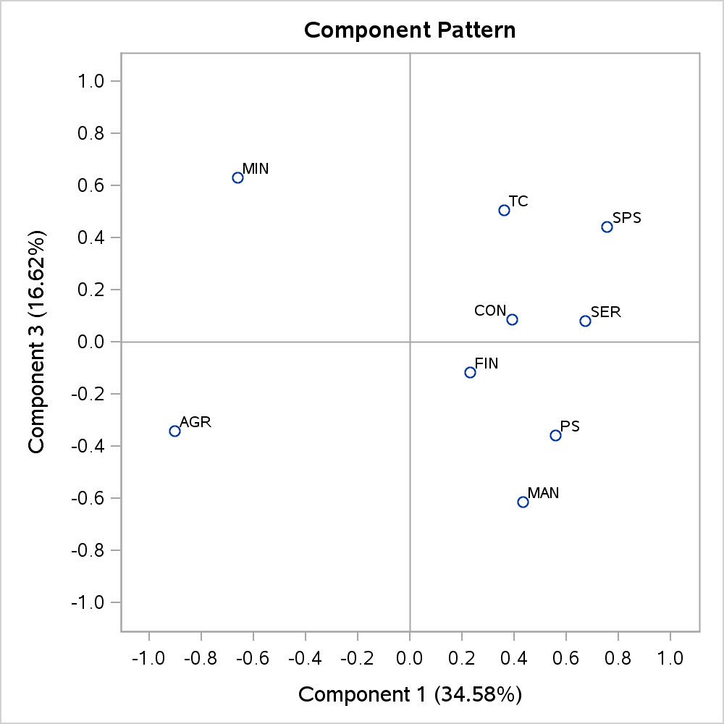

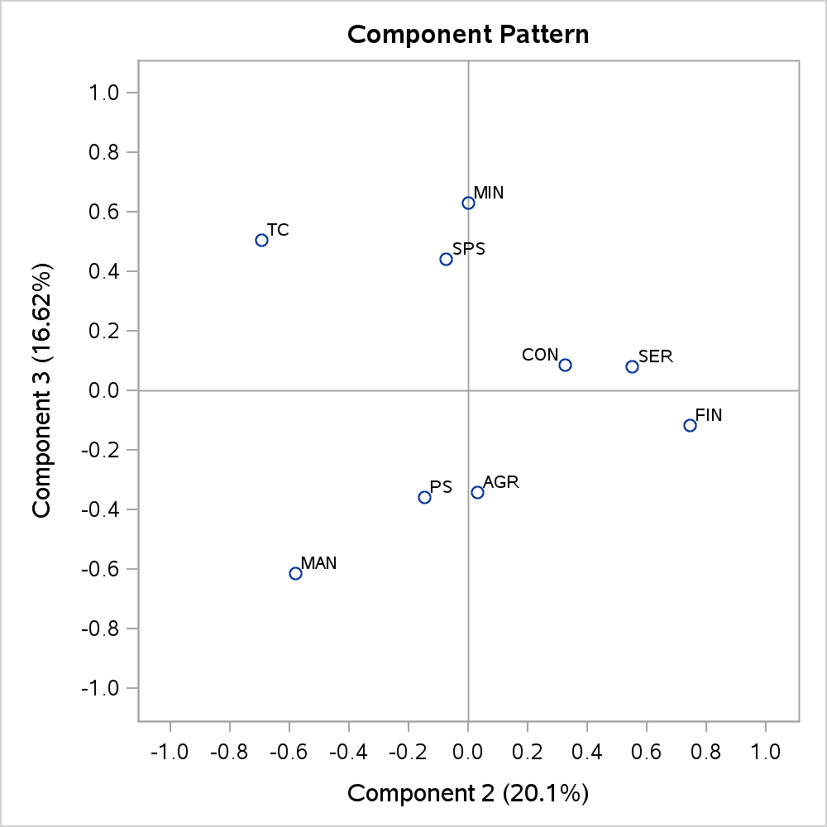

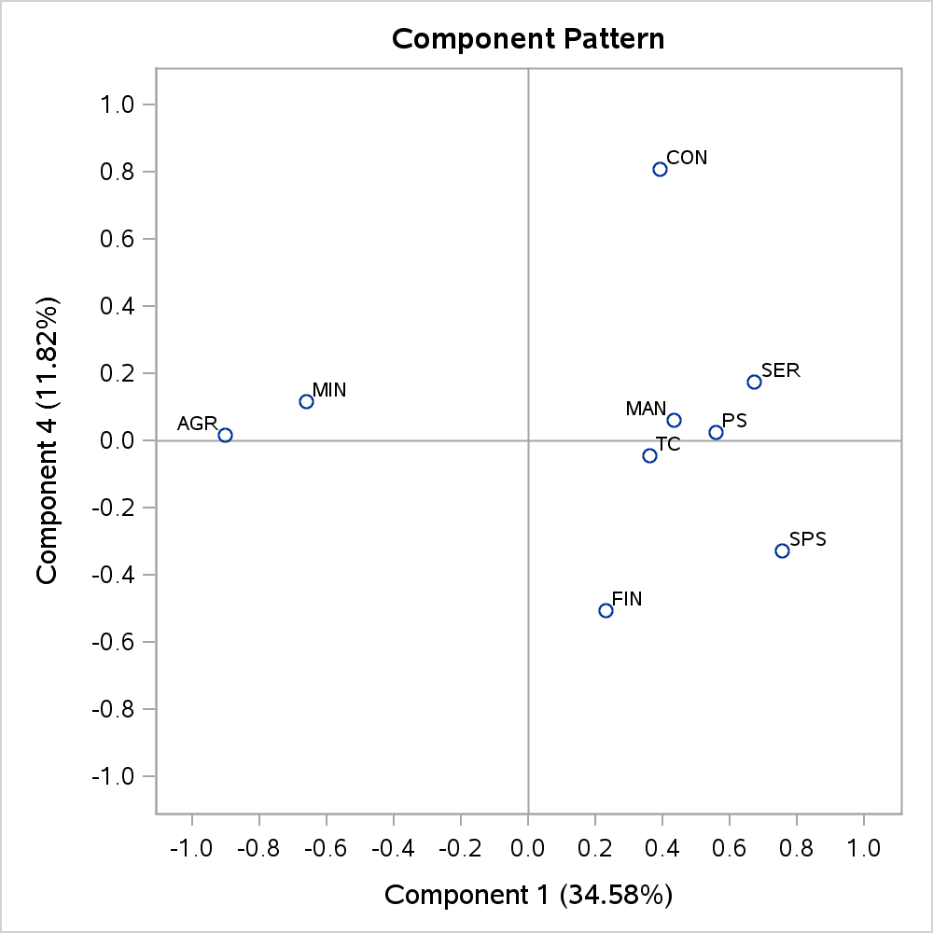

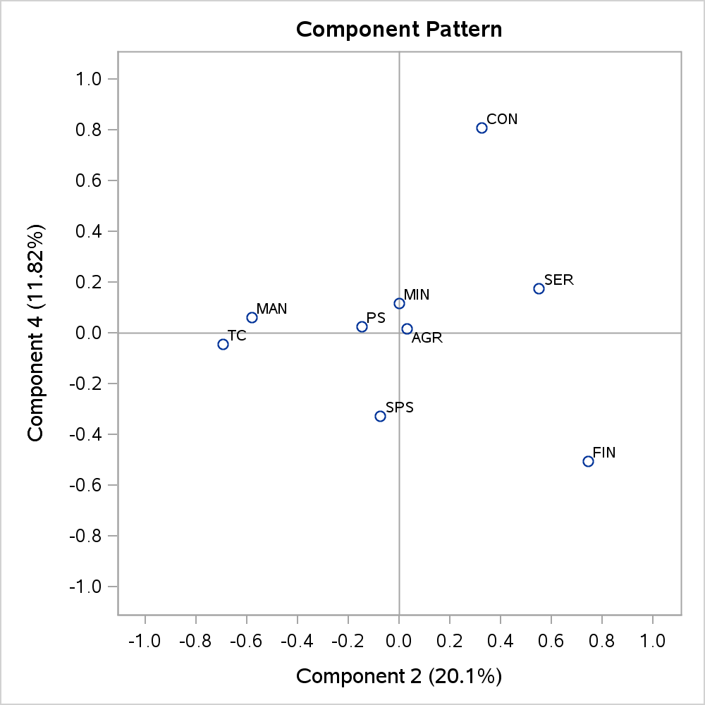

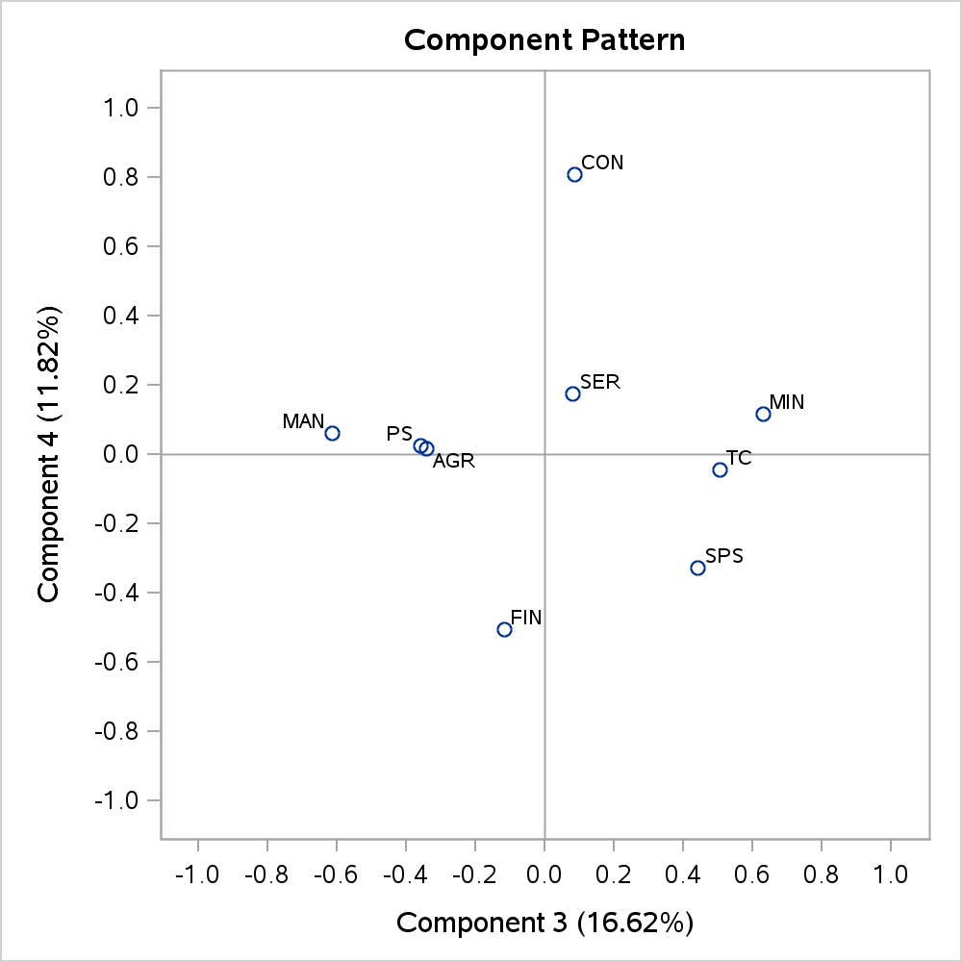

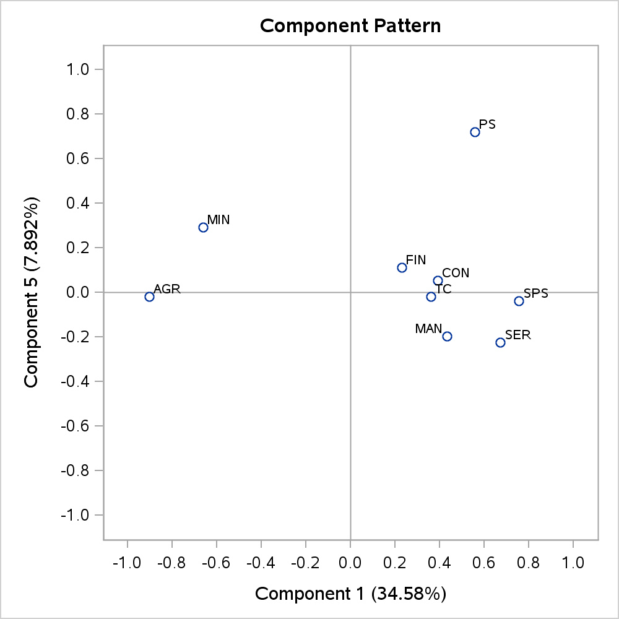

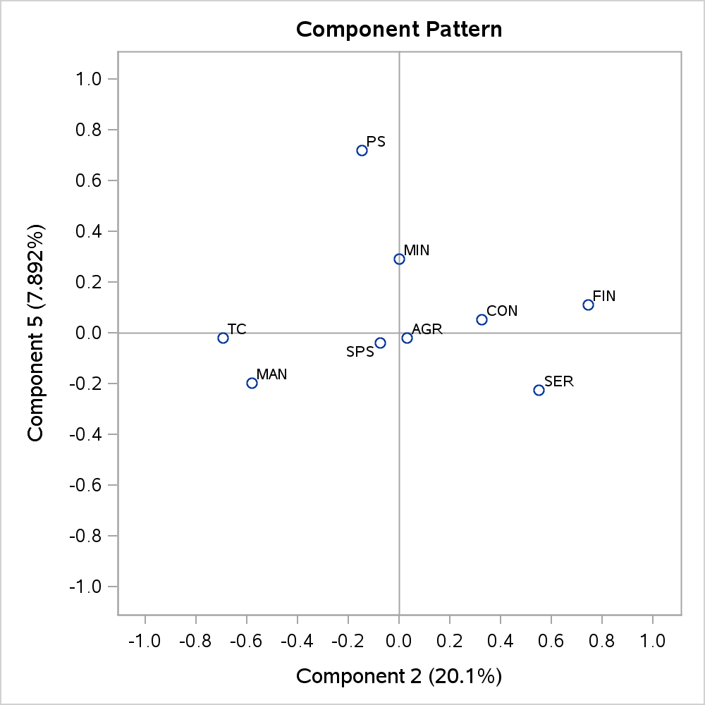

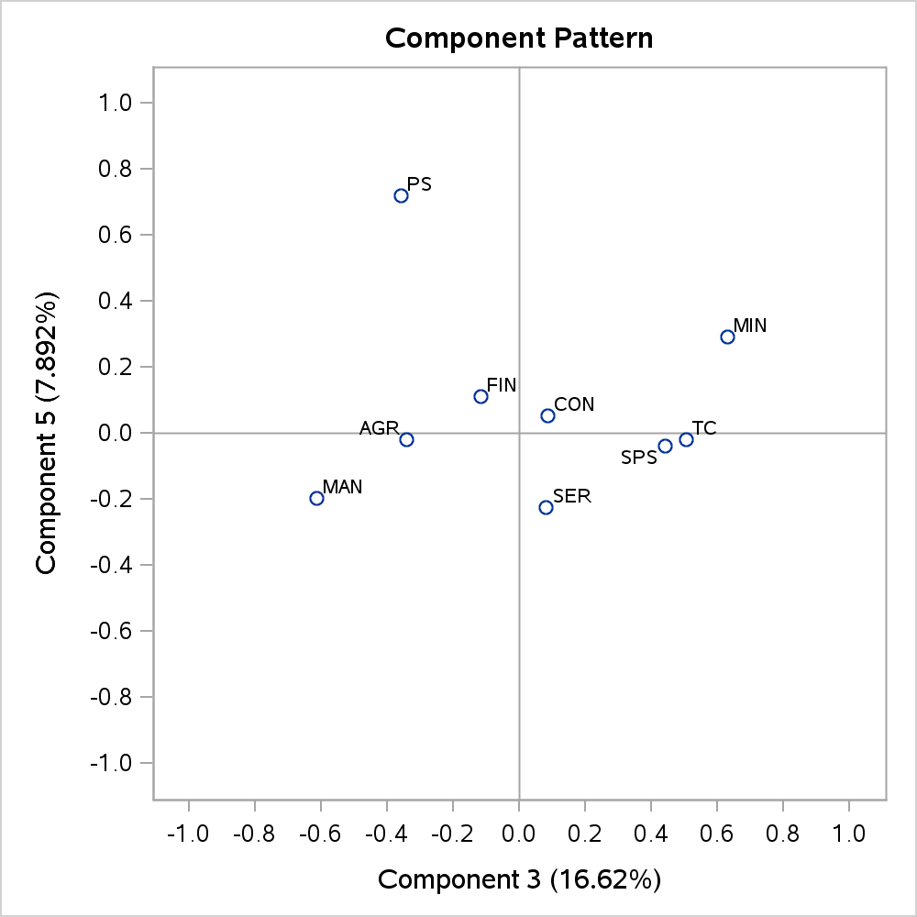

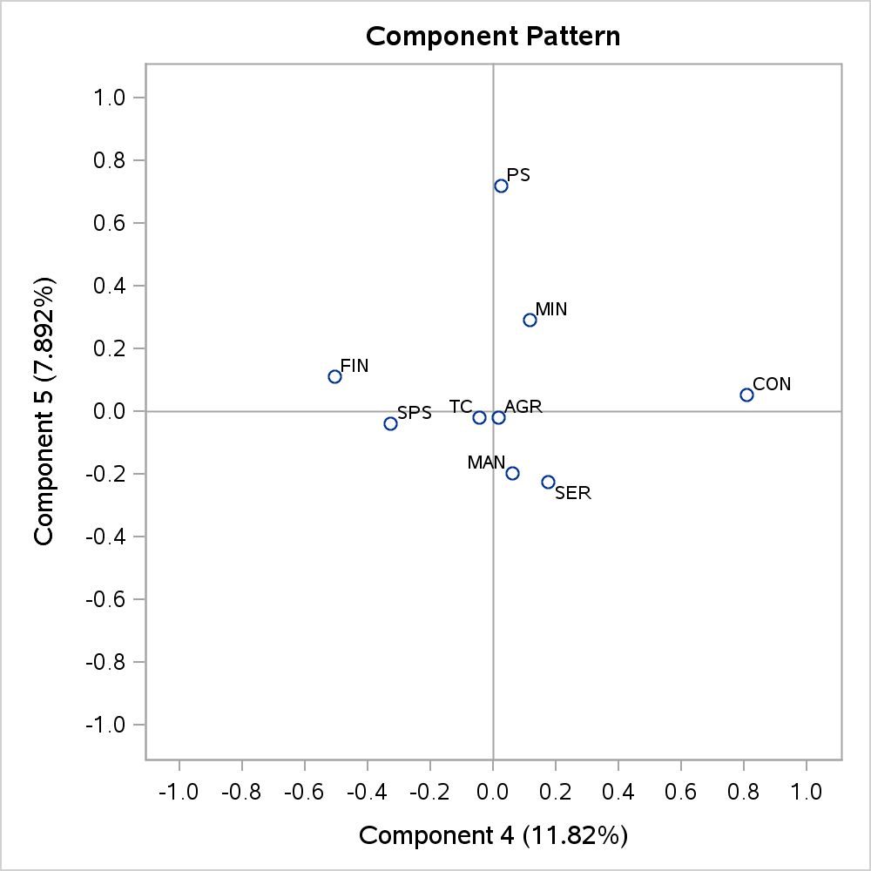

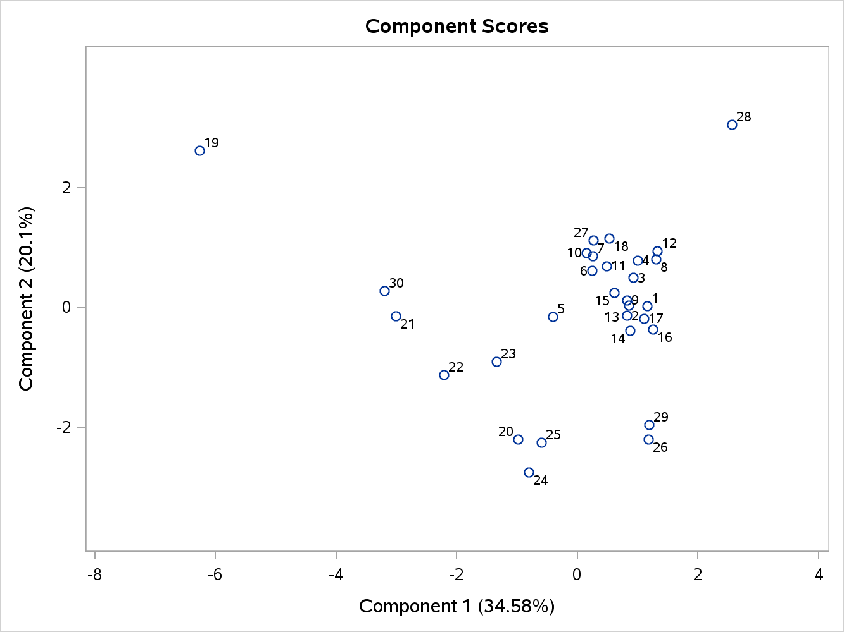

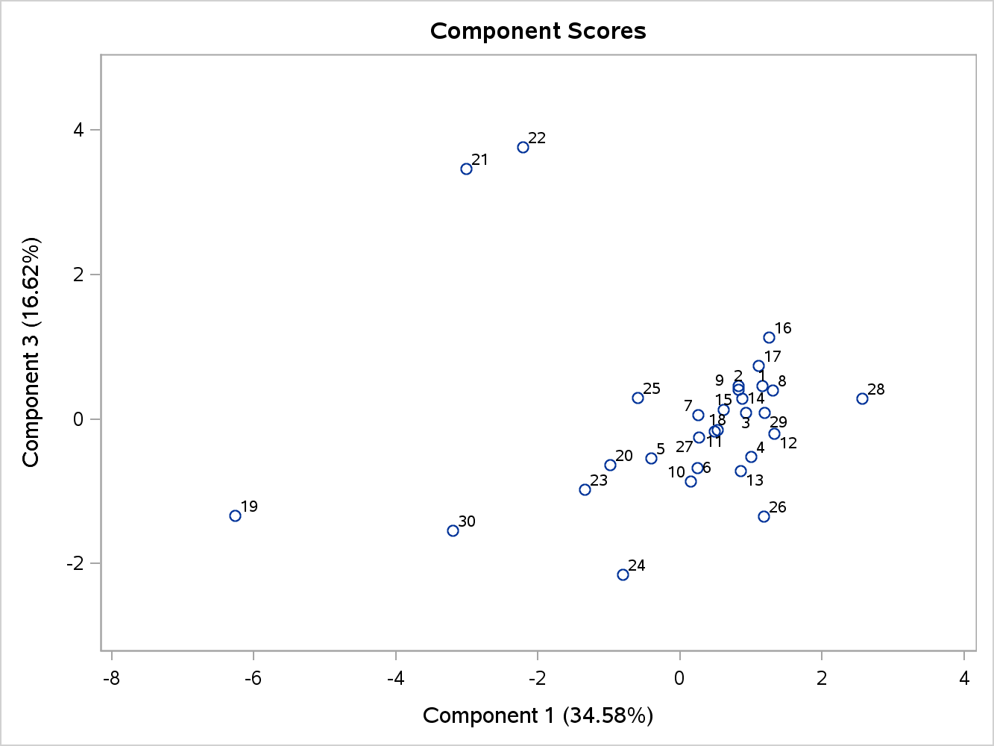

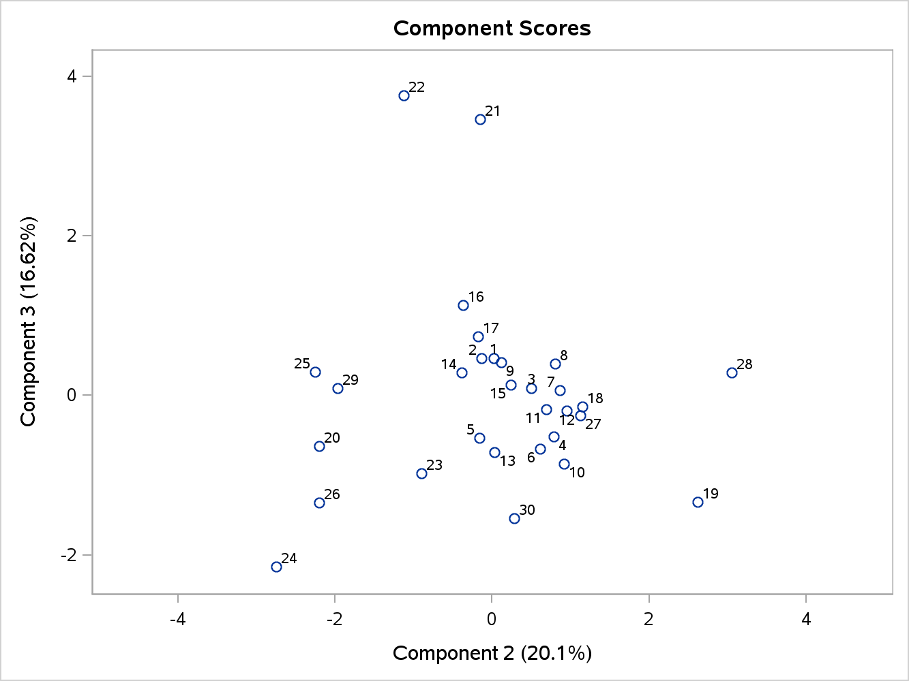

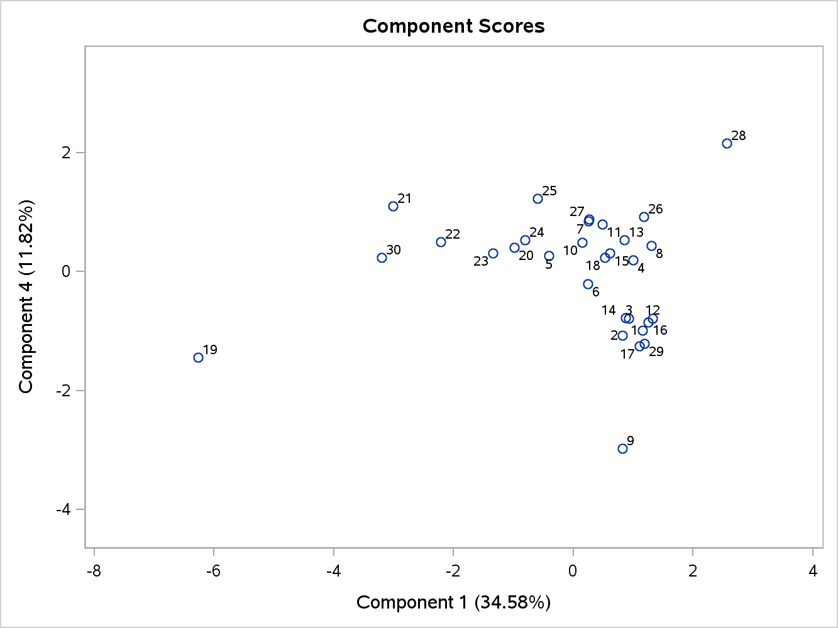

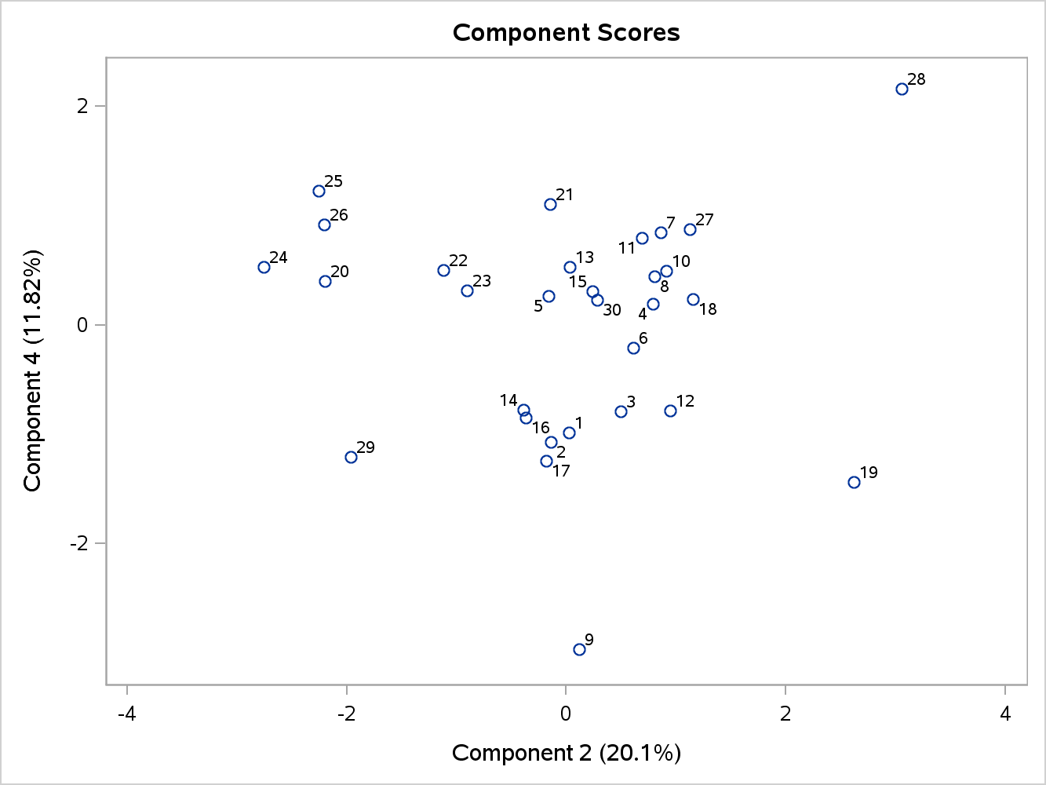

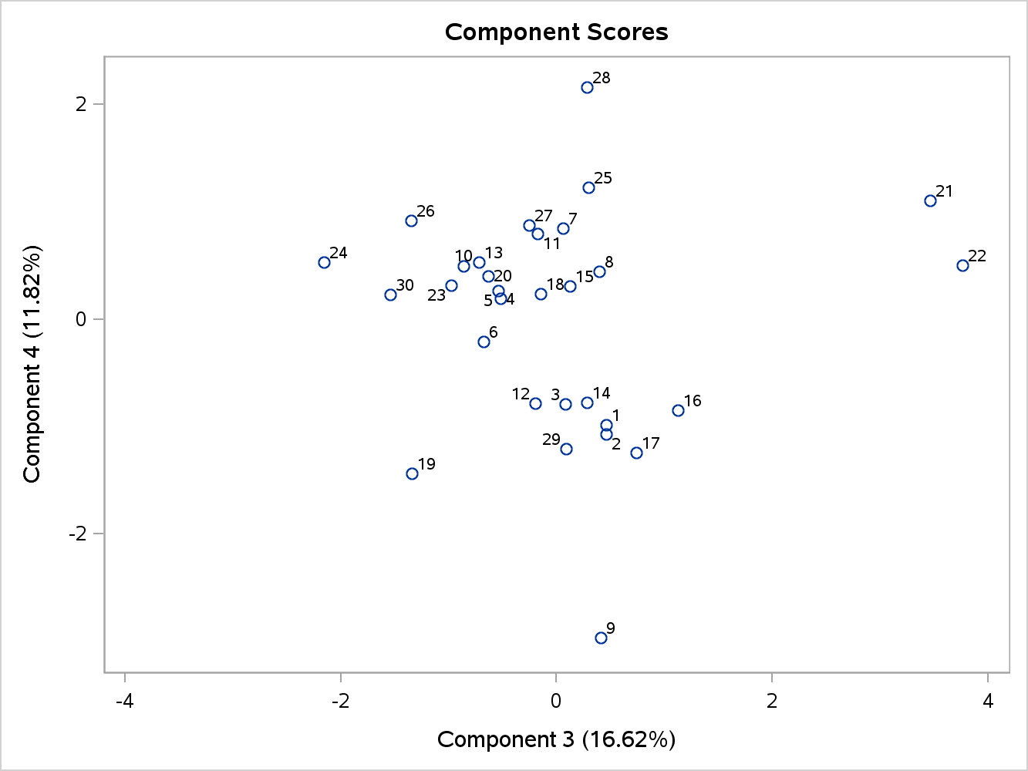

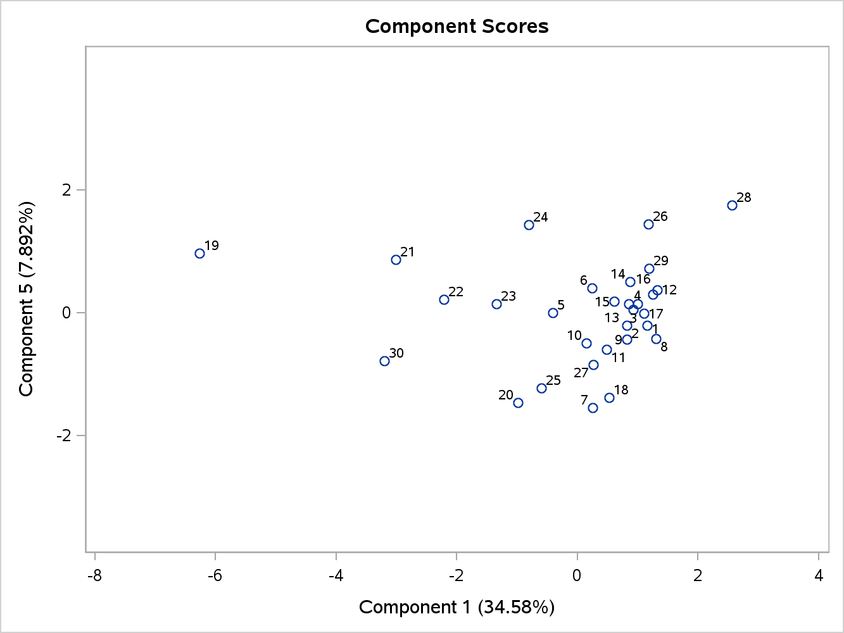

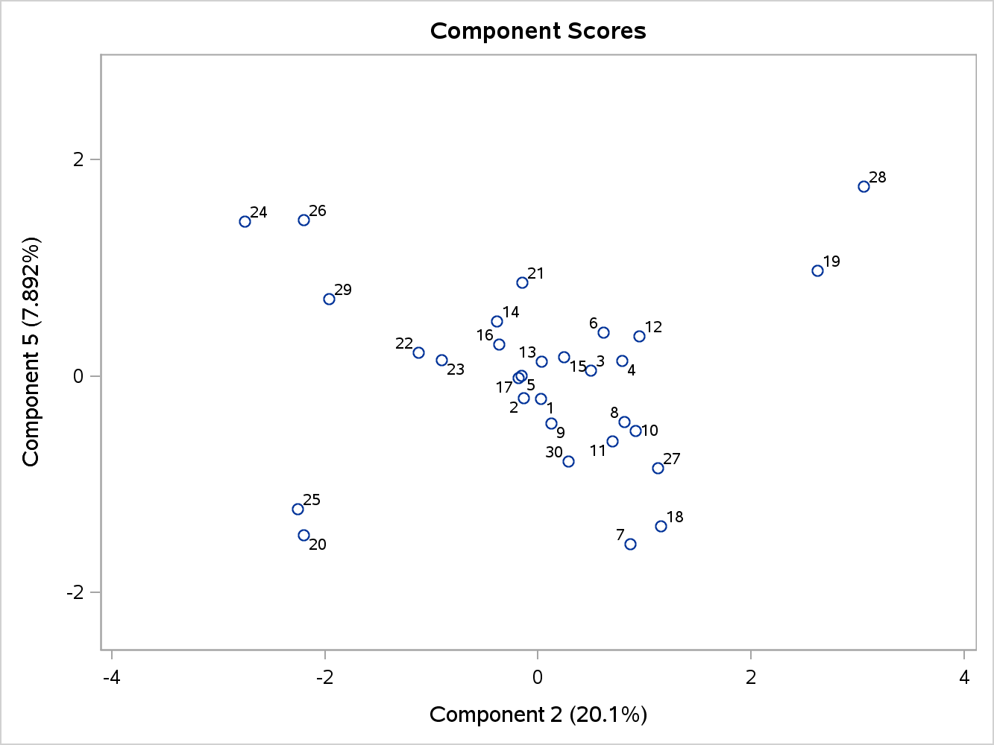

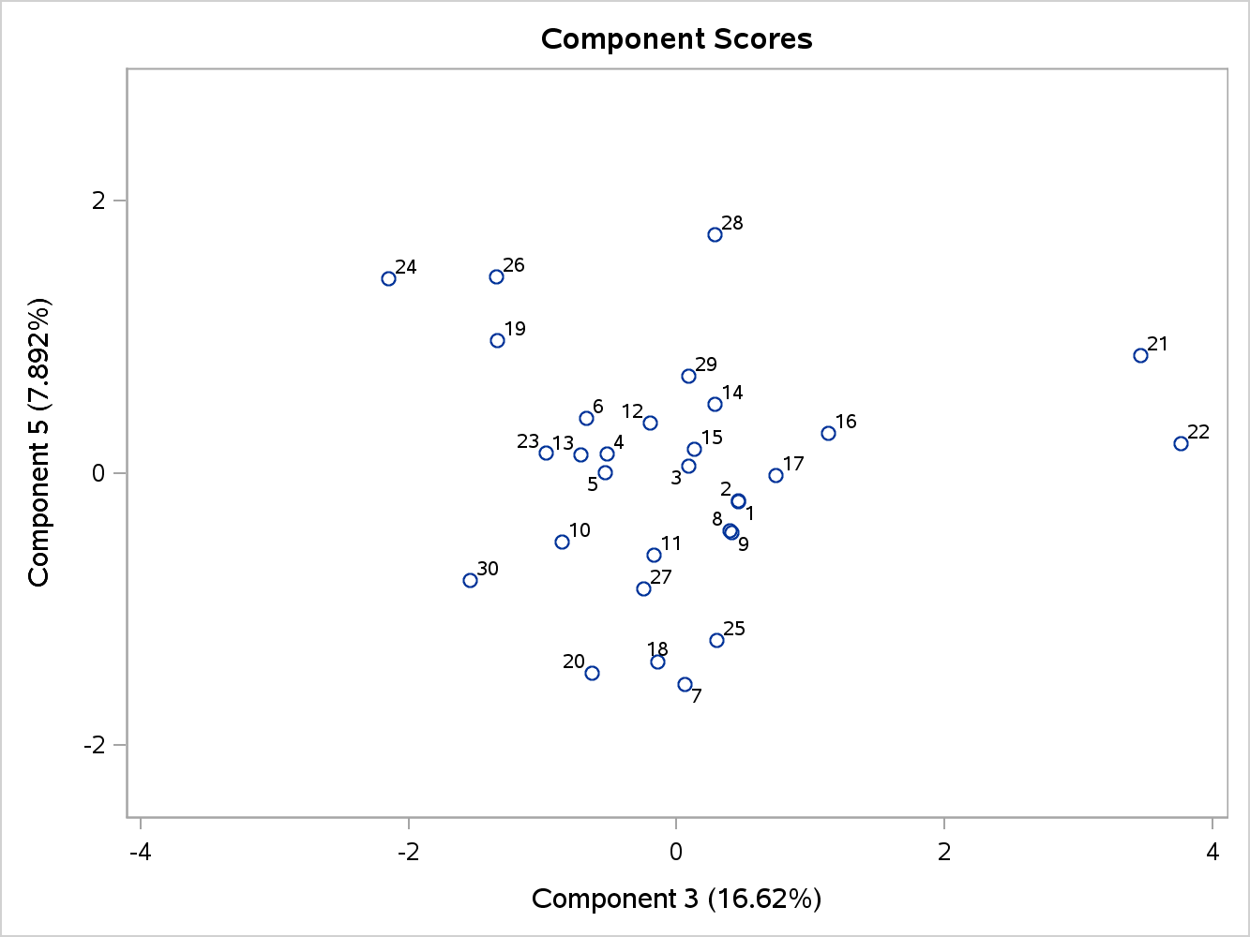

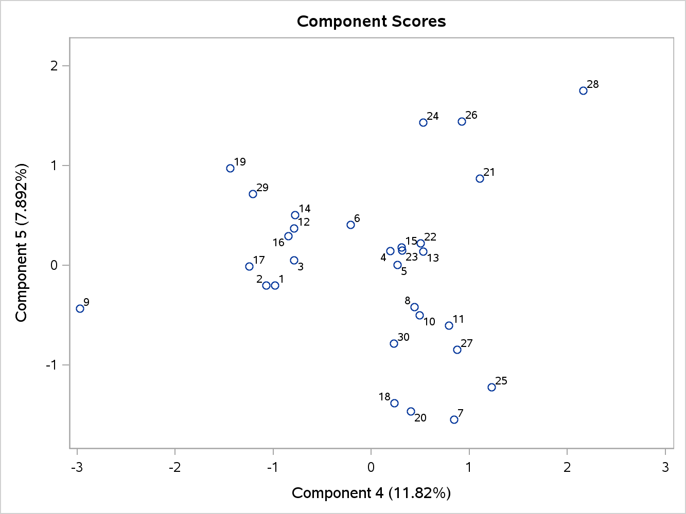

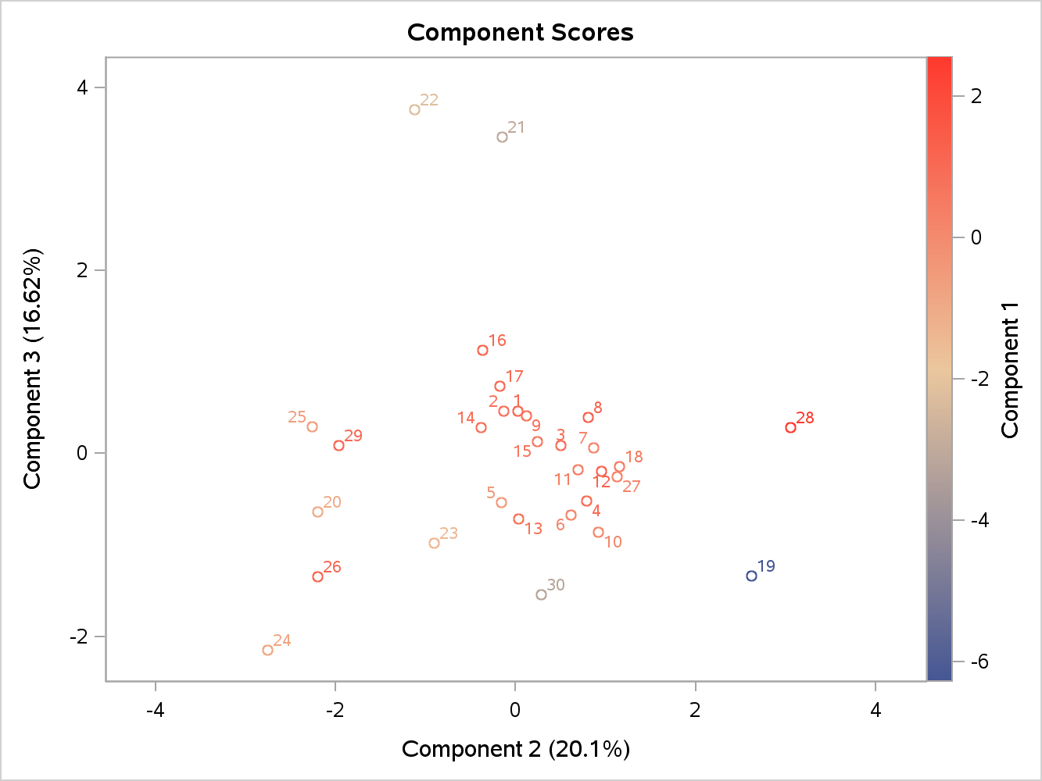

|  |  |
| --- | --- |
| **Input Data Type** | Raw Data |
| **Number of Records Read** | 30 |
| **Number of Records Used** | 30 |
| **N for Significance Tests** | 30 |

|  |
| --- |
| **Prior Communality Estimates: ONE** |

| **Eigenvalues of the Correlation Matrix: Total = 9 Average = 1** | | | | |
| --- | --- | --- | --- | --- |
|  | **Eigenvalue** | **Difference** | **Proportion** | **Cumulative** |
| **1** | 3.11225795 | 1.30302071 | 0.3458 | 0.3458 |
| **2** | 1.80923724 | 0.31301704 | 0.2010 | 0.5468 |
| **3** | 1.49622020 | 0.43277636 | 0.1662 | 0.7131 |
| **4** | 1.06344384 | 0.35318631 | 0.1182 | 0.8312 |
| **5** | 0.71025753 | 0.39891874 | 0.0789 | 0.9102 |
| **6** | 0.31133879 | 0.01791787 | 0.0346 | 0.9448 |
| **7** | 0.29342091 | 0.08960446 | 0.0326 | 0.9774 |
| **8** | 0.20381645 | 0.20380935 | 0.0226 | 1.0000 |
| **9** | 0.00000710 |  | 0.0000 | 1.0000 |

|  |
| --- |
| **9 factors will be retained by the NFACTOR criterion.** |

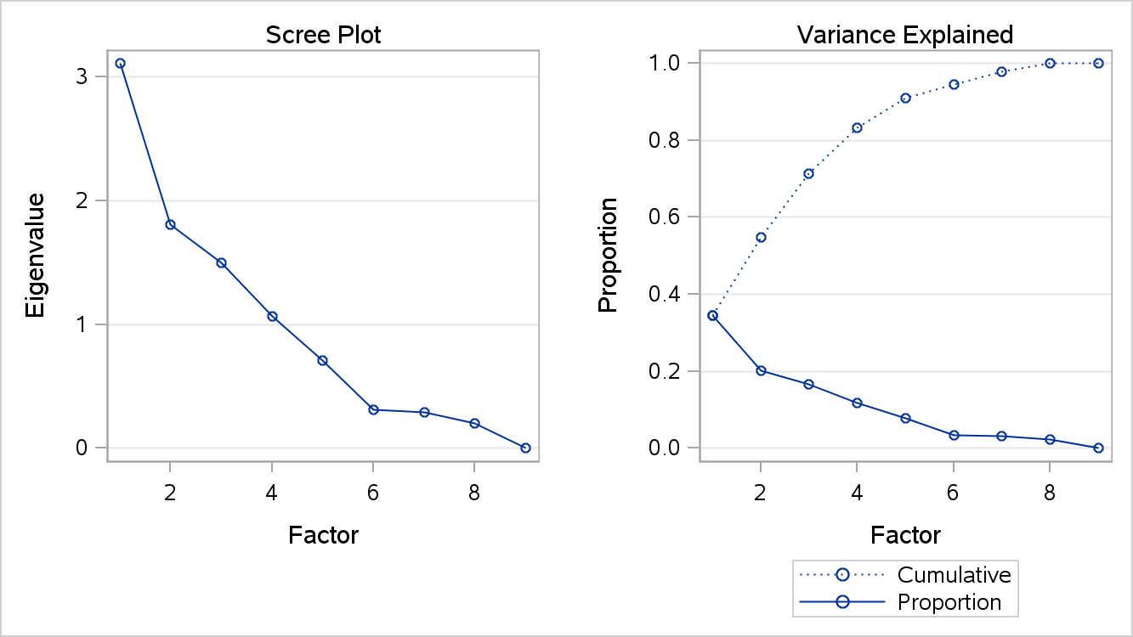

| **Factor Pattern** | | | | | | | | | |
| --- | --- | --- | --- | --- | --- | --- | --- | --- | --- |
|  | **Factor1** | **Factor2** | **Factor3** | **Factor4** | **Factor5** | **Factor6** | **Factor7** | **Factor8** | **Factor9** |
| **AGR** | -0.90235 | 0.03158 | -0.34077 | 0.01701 | -0.02026 | 0.02366 | -0.08861 | 0.24397 | 0.00155 |
| **MIN** | -0.66153 | -0.00066 | 0.63001 | 0.11715 | 0.29186 | -0.11080 | 0.11516 | -0.20252 | 0.00112 |
| **MAN** | 0.43427 | -0.58074 | -0.61412 | 0.06009 | -0.19689 | 0.01725 | 0.12785 | -0.19492 | 0.00119 |
| **PS** | 0.55769 | -0.14681 | -0.35925 | 0.02397 | 0.72010 | -0.11521 | -0.03281 | 0.07003 | 0.00008 |
| **CON** | 0.39094 | 0.32614 | 0.08750 | 0.80711 | 0.05238 | 0.28046 | -0.01099 | 0.01392 | 0.00034 |
| **SER** | 0.67309 | 0.54914 | 0.07969 | 0.17432 | -0.22474 | -0.37535 | 0.09471 | 0.09108 | 0.00065 |
| **FIN** | 0.23126 | 0.74375 | -0.11700 | -0.50450 | 0.11065 | 0.22650 | 0.24790 | -0.01231 | 0.00051 |
| **SPS** | 0.75535 | -0.07358 | 0.44055 | -0.32715 | -0.03853 | 0.08841 | -0.33656 | -0.01872 | 0.00109 |
| **TC** | 0.36178 | -0.69493 | 0.50518 | -0.04338 | -0.01930 | 0.07918 | 0.26659 | 0.22669 | 0.00016 |

| **Variance Explained by Each Factor** | | | | | | | | |
| --- | --- | --- | --- | --- | --- | --- | --- | --- |
| **Factor1** | **Factor2** | **Factor3** | **Factor4** | **Factor5** | **Factor6** | **Factor7** | **Factor8** | **Factor9** |
| 3.1122579 | 1.8092372 | 1.4962202 | 1.0634438 | 0.7102575 | 0.3113388 | 0.2934209 | 0.2038164 | 0.0000071 |

| **Final Communality Estimates: Total = 9.000000** | | | | | | | | |
| --- | --- | --- | --- | --- | --- | --- | --- | --- |
| **AGR** | **MIN** | **MAN** | **PS** | **CON** | **SER** | **FIN** | **SPS** | **TC** |
| 1.0000000 | 1.0000000 | 1.0000000 | 1.0000000 | 1.0000000 | 1.0000000 | 1.0000000 | 1.0000000 | 1.0000000 |

|  |
| --- |
| **Scoring Coefficients Estimated by Regression** |

| **Squared Multiple Correlations of the Variables with Each Factor** | | | | | | | | |
| --- | --- | --- | --- | --- | --- | --- | --- | --- |
| **Factor1** | **Factor2** | **Factor3** | **Factor4** | **Factor5** | **Factor6** | **Factor7** | **Factor8** | **Factor9** |
| 1.0000000 | 1.0000000 | 1.0000000 | 1.0000000 | 1.0000000 | 1.0000000 | 1.0000000 | 1.0000000 | 1.0000000 |

| **Standardized Scoring Coefficients** | | | | | | | | | |
| --- | --- | --- | --- | --- | --- | --- | --- | --- | --- |
|  | **Factor1** | **Factor2** | **Factor3** | **Factor4** | **Factor5** | **Factor6** | **Factor7** | **Factor8** | **Factor9** |
| **AGR** | -0.2899352 | 0.01745251 | -0.2277561 | 0.01599266 | -0.0285226 | 0.0759832 | -0.3019739 | 1.19702447 | 218.469776 |
| **MIN** | -0.2125564 | -0.0003648 | 0.42106913 | 0.11016531 | 0.41092306 | -0.3558825 | 0.39246238 | -0.9936465 | 157.205162 |
| **MAN** | 0.13953465 | -0.3209864 | -0.4104446 | 0.05650521 | -0.2772078 | 0.05540933 | 0.43570729 | -0.9563572 | 167.815802 |
| **PS** | 0.17919035 | -0.0811435 | -0.2401037 | 0.02254142 | 1.01385982 | -0.3700338 | -0.1118089 | 0.34360137 | 11.3549322 |
| **CON** | 0.12561144 | 0.1802652 | 0.05847831 | 0.75896054 | 0.07374625 | 0.9008172 | -0.0374475 | 0.068275 | 48.2914946 |
| **SER** | 0.21627065 | 0.30351818 | 0.0532614 | 0.16391795 | -0.3164255 | -1.2055929 | 0.32276959 | 0.44688931 | 91.9695736 |
| **FIN** | 0.07430646 | 0.41108292 | -0.0782001 | -0.4744002 | 0.15578188 | 0.72751139 | 0.84485715 | -0.0603896 | 71.6018867 |
| **SPS** | 0.24270018 | -0.0406711 | 0.29444003 | -0.3076338 | -0.0542477 | 0.28397703 | -1.1470359 | -0.0918699 | 154.013441 |
| **TC** | 0.11624271 | -0.3841038 | 0.33763521 | -0.0407893 | -0.0271733 | 0.25430786 | 0.90854769 | 1.11222071 | 22.8002052 |

|  |  |
| --- | --- |
| **Input Data Type** | Raw Data |
| **Number of Records Read** | 30 |
| **Number of Records Used** | 30 |
| **N for Significance Tests** | 30 |

|  |
| --- |
| **Prior Communality Estimates: ONE** |

| **Preliminary Eigenvalues: Total = 9 Average = 1** | | | | |
| --- | --- | --- | --- | --- |
|  | **Eigenvalue** | **Difference** | **Proportion** | **Cumulative** |
| **1** | 3.11225795 | 1.30302071 | 0.3458 | 0.3458 |
| **2** | 1.80923724 | 0.31301704 | 0.2010 | 0.5468 |
| **3** | 1.49622020 | 0.43277636 | 0.1662 | 0.7131 |
| **4** | 1.06344384 | 0.35318631 | 0.1182 | 0.8312 |
| **5** | 0.71025753 | 0.39891874 | 0.0789 | 0.9102 |
| **6** | 0.31133879 | 0.01791787 | 0.0346 | 0.9448 |
| **7** | 0.29342091 | 0.08960446 | 0.0326 | 0.9774 |
| **8** | 0.20381645 | 0.20380935 | 0.0226 | 1.0000 |
| **9** | 0.00000710 |  | 0.0000 | 1.0000 |

|  |
| --- |
| **9 factors will be retained by the NFACTOR criterion.** |

|  |  |
| --- | --- |
| **Warning:** | Too many factors for a unique solution. |



| **Iteration** | **Change** | **Communalities** | | | | | | | | |
| --- | --- | --- | --- | --- | --- | --- | --- | --- | --- | --- |
| **1** | 0.0000 | 1.00000 | 1.00000 | 1.00000 | 1.00000 | 1.00000 | 1.00000 | 1.00000 | 1.00000 | 1.00000 |

|  |  |
| --- | --- |
| **Error:** | Communality greater than 1.0. |

|  |  |
| --- | --- |
| **Input Data Type** | Raw Data |
| **Number of Records Read** | 30 |
| **Number of Records Used** | 30 |
| **N for Significance Tests** | 30 |

| **Prior Communality Estimates: SMC** | | | | | | | | |
| --- | --- | --- | --- | --- | --- | --- | --- | --- |
| **AGR** | **MIN** | **MAN** | **PS** | **CON** | **SER** | **FIN** | **SPS** | **TC** |
| 0.99997905 | 0.99995954 | 0.99996449 | 0.99232698 | 0.99957146 | 0.99988180 | 0.99980501 | 0.99995784 | 0.99808522 |

| **Preliminary Eigenvalues: Total = 7643.58071 Average = 849.286745** | | | | |
| --- | --- | --- | --- | --- |
|  | **Eigenvalue** | **Difference** | **Proportion** | **Cumulative** |
| **1** | 2854.77142 | 1249.29164 | 0.3735 | 0.3735 |
| **2** | 1605.47978 | 339.81854 | 0.2100 | 0.5835 |
| **3** | 1265.66123 | 205.60156 | 0.1656 | 0.7491 |
| **4** | 1060.05967 | 721.00024 | 0.1387 | 0.8878 |
| **5** | 339.05943 | 66.35937 | 0.0444 | 0.9322 |
| **6** | 272.70007 | 113.29215 | 0.0357 | 0.9678 |
| **7** | 159.40792 | 71.97375 | 0.0209 | 0.9887 |
| **8** | 87.43417 | 88.42714 | 0.0114 | 1.0001 |
| **9** | -0.99297 |  | -0.0001 | 1.0000 |

|  |
| --- |
| **2 factors will be retained by the NFACTOR criterion.** |

| **Iteration** | **Criterion** | **Ridge** | **Change** | **Communalities** | | | | | | | | |
| --- | --- | --- | --- | --- | --- | --- | --- | --- | --- | --- | --- | --- |
| **1** | 11.3654961 | 0.0000 | 0.8835 | 0.82598 | 0.32044 | 0.97094 | 0.24006 | 0.11555 | 0.72891 | 0.12447 | 0.43365 | 0.21456 |
| **2** | 10.1887401 | 0.0000 | 0.7009 | 0.99882 | 0.27870 | 1.67185 | 0.16167 | 0.16052 | 0.33315 | 0.09960 | 0.58354 | 0.11491 |

|  |
| --- |
| ERROR: Communality greater than 1.0. |

| **Significance Tests Based on 30 Observations** | | | |
| --- | --- | --- | --- |
| **Test** | **DF** | **Chi-Square** | **Pr > ChiSq** |
| **H0: No common factors** | 36 | 352.0494 | <.0001 |
| **HA: At least one common factor** |  |  |  |

|  |  |
| --- | --- |
| **Chi-Square without Bartlett's Correction** | 405.67277 |
| **Akaike's Information Criterion** | 333.67277 |
| **Schwarz's Bayesian Criterion** | 283.22967 |
| **Tucker and Lewis's Reliability Coefficient** | 0.00000 |

|  |  |
| --- | --- |
| **Input Data Type** | Raw Data |
| **Number of Records Read** | 30 |
| **Number of Records Used** | 30 |
| **N for Significance Tests** | 30 |

| **Prior Communality Estimates: SMC** | | | | | | | | |
| --- | --- | --- | --- | --- | --- | --- | --- | --- |
| **AGR** | **MIN** | **MAN** | **PS** | **CON** | **SER** | **FIN** | **SPS** | **TC** |
| 0.99997905 | 0.99995954 | 0.99996449 | 0.99232698 | 0.99957146 | 0.99988180 | 0.99980501 | 0.99995784 | 0.99808522 |

| **Preliminary Eigenvalues: Total = 8.9895314 Average = 0.99883682** | | | | |
| --- | --- | --- | --- | --- |
|  | **Eigenvalue** | **Difference** | **Proportion** | **Cumulative** |
| **1** | 3.11135025 | 1.30282608 | 0.3461 | 0.3461 |
| **2** | 1.80852417 | 0.31331869 | 0.2012 | 0.5473 |
| **3** | 1.49520548 | 0.43208655 | 0.1663 | 0.7136 |
| **4** | 1.06311893 | 0.35848481 | 0.1183 | 0.8319 |
| **5** | 0.70463412 | 0.39385892 | 0.0784 | 0.9103 |
| **6** | 0.31077520 | 0.01791380 | 0.0346 | 0.9448 |
| **7** | 0.29286141 | 0.08974278 | 0.0326 | 0.9774 |
| **8** | 0.20311862 | 0.20317540 | 0.0226 | 1.0000 |
| **9** | -.00005678 |  | -0.0000 | 1.0000 |

|  |
| --- |
| **2 factors will be retained by the NFACTOR criterion.** |

| **Iteration** | **Criterion** | **Ridge** | **Change** | **Communalities** | | | | | | | | |
| --- | --- | --- | --- | --- | --- | --- | --- | --- | --- | --- | --- | --- |
| **1** | 0.7192671 | 0.0000 | 0.8782 | 0.86867 | 0.30785 | 0.34133 | 0.21199 | 0.12137 | 0.74471 | 0.38212 | 0.46473 | 0.45379 |
| **2** | 0.7099061 | 0.0000 | 0.0974 | 0.93098 | 0.27906 | 0.25722 | 0.19720 | 0.14420 | 0.73335 | 0.38589 | 0.50300 | 0.55123 |
| **3** | 0.7066696 | 0.0000 | 0.0878 | 0.94852 | 0.27596 | 0.21289 | 0.18770 | 0.14325 | 0.71365 | 0.37770 | 0.51637 | 0.63899 |
| **4** | 0.7057259 | 0.0000 | 0.0532 | 0.95519 | 0.27816 | 0.19055 | 0.18371 | 0.14249 | 0.69796 | 0.37183 | 0.52326 | 0.69223 |
| **5** | 0.7054876 | 0.0000 | 0.0285 | 0.95773 | 0.28036 | 0.17990 | 0.18211 | 0.14190 | 0.68886 | 0.36795 | 0.52656 | 0.72074 |
| **6** | 0.7054318 | 0.0000 | 0.0142 | 0.95871 | 0.28173 | 0.17488 | 0.18146 | 0.14159 | 0.68414 | 0.36579 | 0.52810 | 0.73493 |
| **7** | 0.7054192 | 0.0000 | 0.0068 | 0.95911 | 0.28246 | 0.17253 | 0.18119 | 0.14143 | 0.68181 | 0.36470 | 0.52882 | 0.74175 |
| **8** | 0.7054165 | 0.0000 | 0.0032 | 0.95928 | 0.28282 | 0.17143 | 0.18106 | 0.14135 | 0.68070 | 0.36417 | 0.52915 | 0.74497 |
| **9** | 0.7054159 | 0.0000 | 0.0015 | 0.95936 | 0.28299 | 0.17091 | 0.18101 | 0.14132 | 0.68017 | 0.36392 | 0.52931 | 0.74648 |
| **10** | 0.7054157 | 0.0000 | 0.0007 | 0.95939 | 0.28308 | 0.17068 | 0.18098 | 0.14130 | 0.67993 | 0.36380 | 0.52938 | 0.74719 |

|  |
| --- |
| Convergence criterion satisfied. |

| **Eigenvalues of the Reduced Correlation Matrix: Total = 4.05572183 Average = 0.45063576** | | | | |
| --- | --- | --- | --- | --- |
|  | **Eigenvalue** | **Difference** | **Proportion** | **Cumulative** |
| **1** | 2.71285754 | 1.36999310 | 0.6689 | 0.6689 |
| **2** | 1.34286444 | 0.49285732 | 0.3311 | 1.0000 |
| **3** | 0.85000713 | 0.49691989 | 0.2096 | 1.2096 |
| **4** | 0.35308723 | 0.31810025 | 0.0871 | 1.2966 |
| **5** | 0.03498698 | 0.15226038 | 0.0086 | 1.3053 |
| **6** | -.11727340 | 0.04386359 | -0.0289 | 1.2764 |
| **7** | -.16113699 | 0.14231528 | -0.0397 | 1.2366 |
| **8** | -.30345226 | 0.35276659 | -0.0748 | 1.1618 |
| **9** | -.65621886 |  | -0.1618 | 1.0000 |

| **Factor Pattern** | | |
| --- | --- | --- |
|  | **Factor1** | **Factor2** |
| **AGR** | -0.97517 | 0.09194 |
| **MIN** | -0.51286 | -0.14170 |
| **MAN** | 0.31559 | -0.26646 |
| **PS** | 0.42467 | -0.02506 |
| **CON** | 0.31070 | 0.21156 |
| **SER** | 0.64894 | 0.50869 |
| **FIN** | 0.19552 | 0.57058 |
| **SPS** | 0.71530 | -0.13326 |
| **TC** | 0.38911 | -0.77192 |

| **Variance Explained by Each Factor** | |
| --- | --- |
| **Factor1** | **Factor2** |
| 2.7128575 | 1.3428644 |

| **Final Communality Estimates: Total = 4.055722** | | | | | | | | |
| --- | --- | --- | --- | --- | --- | --- | --- | --- |
| **AGR** | **MIN** | **MAN** | **PS** | **CON** | **SER** | **FIN** | **SPS** | **TC** |
| 0.95940511 | 0.28310262 | 0.17059636 | 0.18097402 | 0.14129021 | 0.67989023 | 0.36379165 | 0.52941077 | 0.74726102 |

|  |
| --- |
| **Scoring Coefficients Estimated by Regression** |

| **Squared Multiple Correlations of the Variables with Each Factor** | |
| --- | --- |
| **Factor1** | **Factor2** |
| 794.03152 | 158.08930 |

| **Standardized Scoring Coefficients** | | |
| --- | --- | --- |
|  | **Factor1** | **Factor2** |
| **AGR** | -6153.1173 | 2739.75151 |
| **MIN** | -4427.1994 | 1971.54521 |
| **MAN** | -4725.8313 | 2104.52146 |
| **PS** | -319.72114 | 142.396713 |
| **CON** | -1359.9935 | 605.590638 |
| **SER** | -2589.7889 | 1153.77581 |
| **FIN** | -2016.3959 | 898.085209 |
| **SPS** | -4337.1916 | 1931.4548 |
| **TC** | -642.05916 | 285.231558 |